W211 Rear Bumper Skirt & 2×2 Muffler Tips Installation Instruction
- The following parts are included in the kit:
Centre Bumper Skirt, 2 Muffler Tip Eyebrows, 2x2 Muffler Tips, Templet of Bumper Cutting, 10pcs Nut No.1, 12pcs Washer No.1, 4pcs Screw No.1, 4pcs Nut No.2, 4pcs Washer No.2, Wrench.

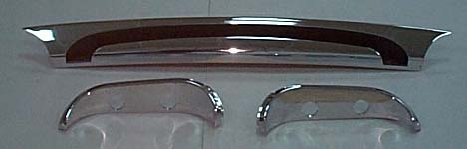 |  | 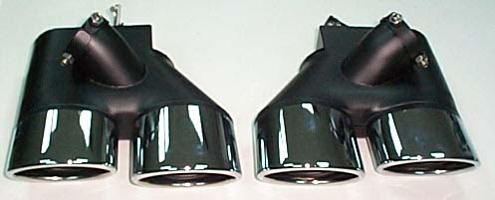
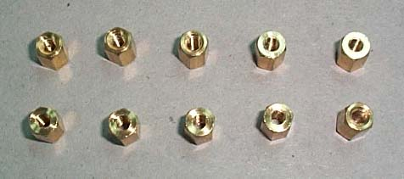 | 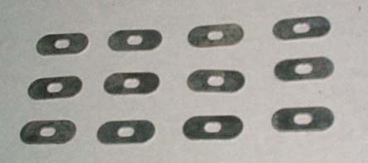 |  | 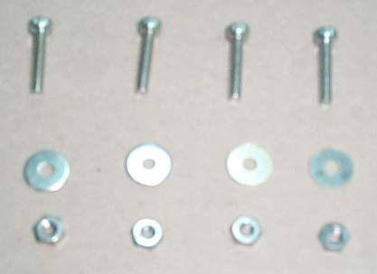
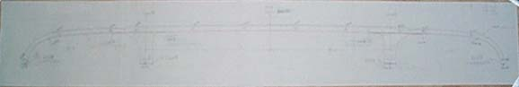 |  |  | 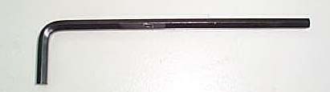

- You will need the following tools for this installation: 6mm & 13mm Socket Wrench and Socket Driver, Electric Drill, 7mm Bit, Air Saw.

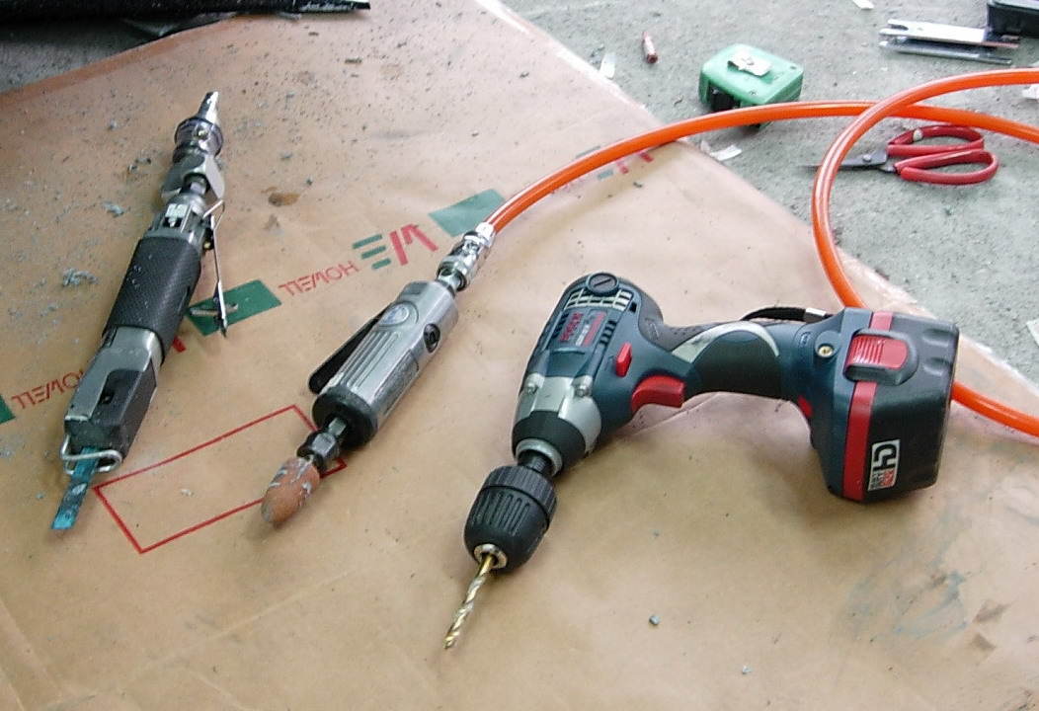
- Measure the center point of the trunk lid moulding then make the line from the center point of the big star on the trunk lid through the center point of the trunk lid moulding down to the bottom edge of the rear bumper. You will get the center line 1 of the rear bumper (picture 1). Next, you need to make line 2 and 3 at the right side and left side of the center line 1 by 30cm (picture 2). Stick the templet of bumper cutting onto the rear bumper, but you have to let the center line , line and line on the templet of bumper cutting match onto the center line 1, line 2 and line 3 on the rear bumper you made. You also need to let lines , , and on the templet of bumper cutting match onto the bottom edge of the rear bumper.

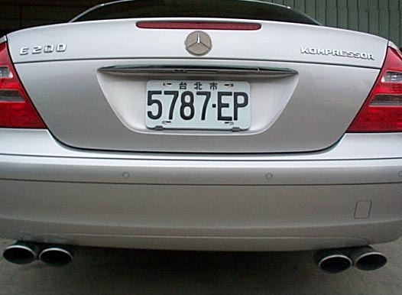PICTURE 1

PICTURE 2 PICTURE 3
- After stuck the templet, you have to use a pin to do the drilling marks for drilling screw holes (total 12 holes) onto the bumper according to the red circles on the templet of bumper cutting.
5. Cut the bumper skirt hole by the air saw machine according to the line of the templet of bumper cutting. (picuture 5 .6 & 7)

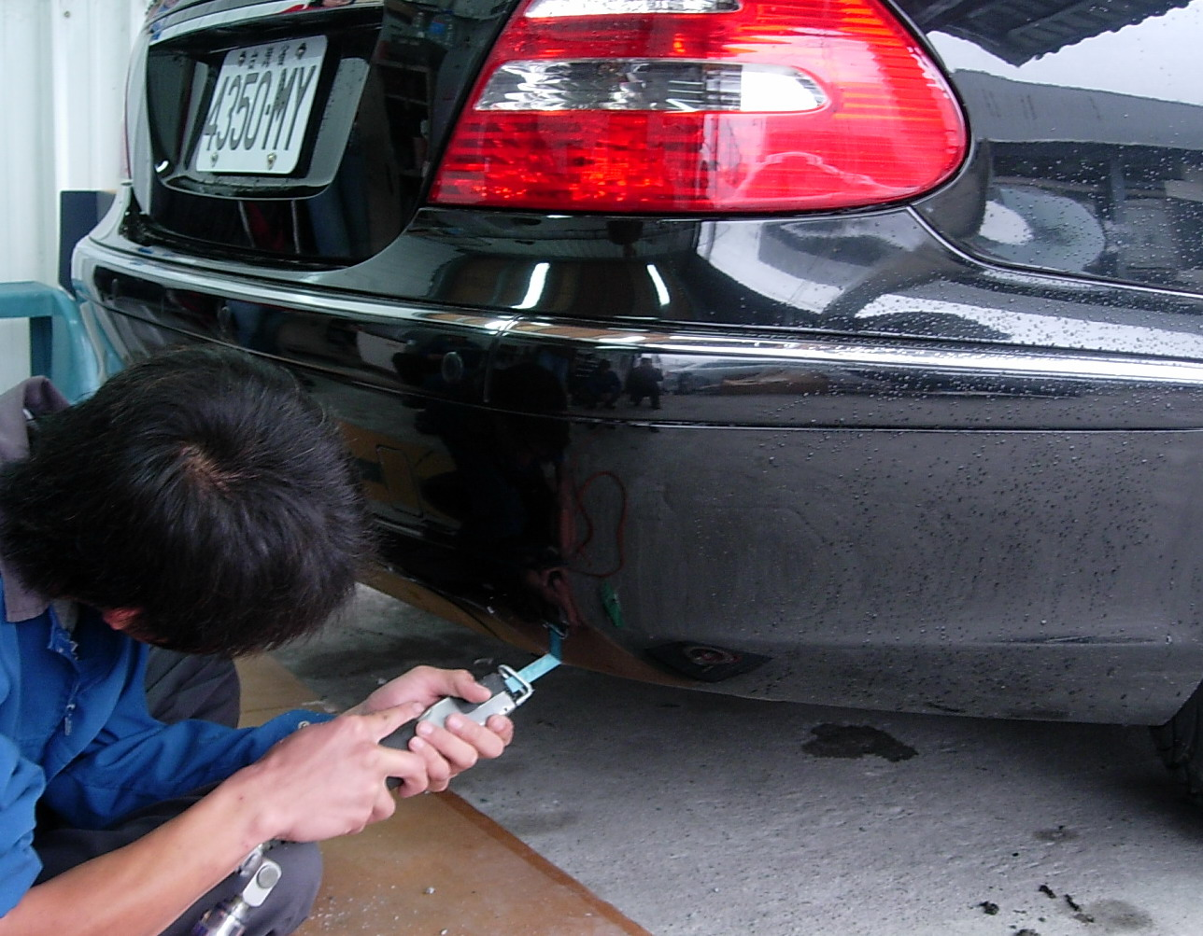PICTURE 5 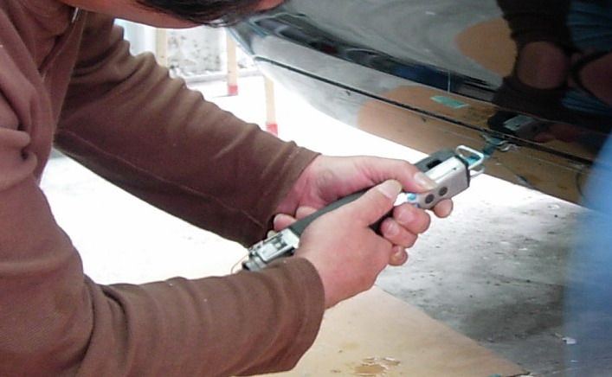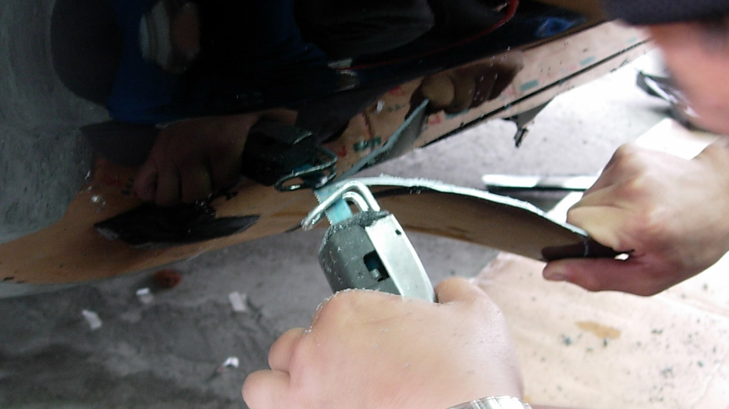
PICTURE 6 PICTURE 7

6. Tear off the templet from the bumper. Drill the screw holes (total 12 holes) by the electric drill machine according to the red circles on the templet of bumper cutting.
(picuture 4 & 4-1)

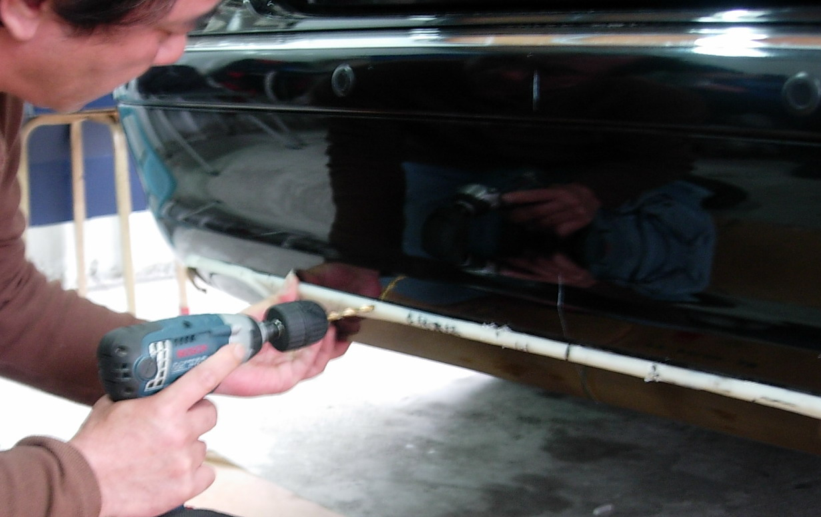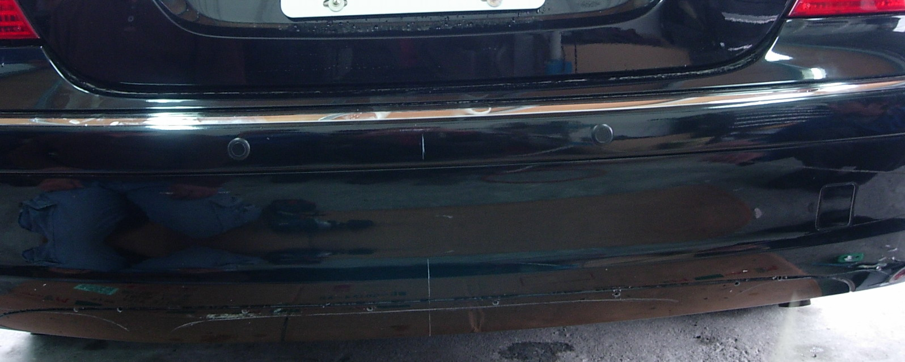
PICTURE 4 PICTURE 4-1

- Prepare to install the bumper skirt. You need to assemble the bumper skirt and 2 pcs muffler tip eyebrow with 2 pcs screw No.1, 2 pcs nut No.2, 2 pcs washer No.1 and 2 pcs washer No. 2 (picture 3). Next, install this bumper skirt assy onto the correct position of the rear bumper after above point 4 and 5 then use 10 pcs nuts No.1 and 10 pcs washer No. 1 to screw the bumper skirt assy to the rear bumper from hole to hole and use screw No. 1, nut No.2, washer No.1 and washer No. 2 to screw the hole and hole . After this, the bumper skirt and eyebrows are installed completely.
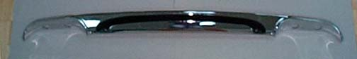PICTURE 8

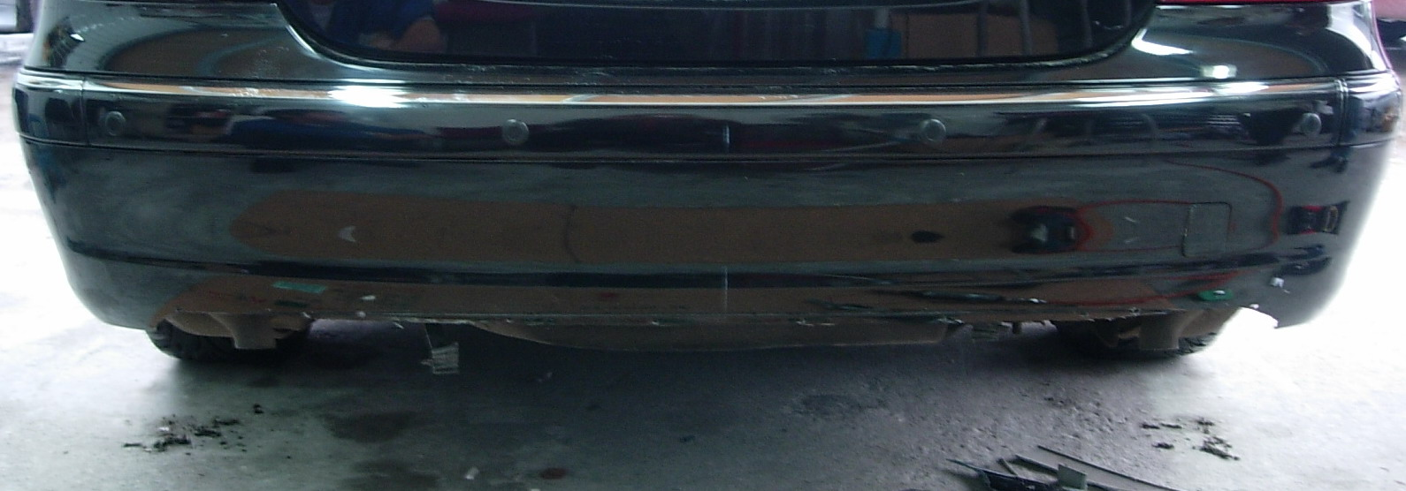PICTURE 9

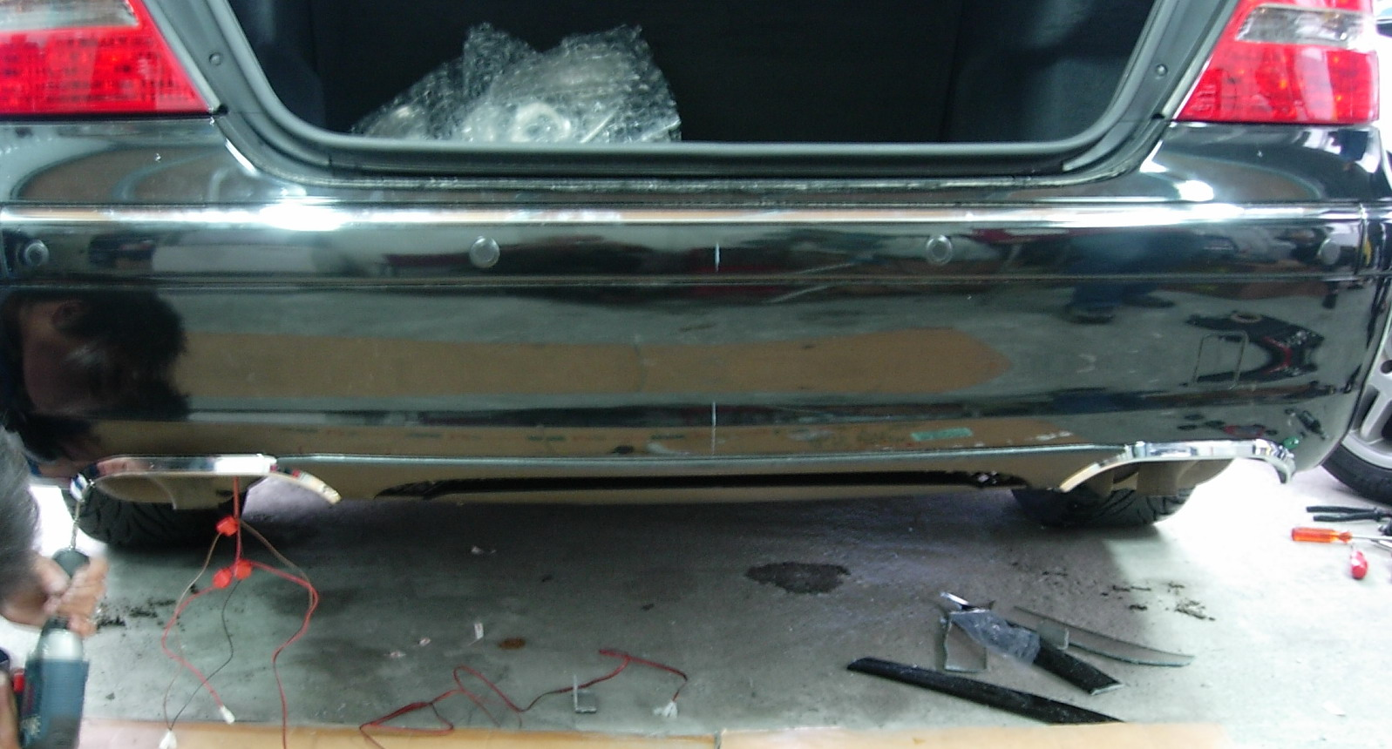PICTURE 10
- Next, install the 2x2 muffler tips. Insert the end pipe of the original muffler into the 2x2 muffler tips and screw it. Use the hook of the 2x2 muffler tips to hang on the edge of the mufflers and screw it.
- The installation is now complete.(PICTURE 11 &PICTURE 12)

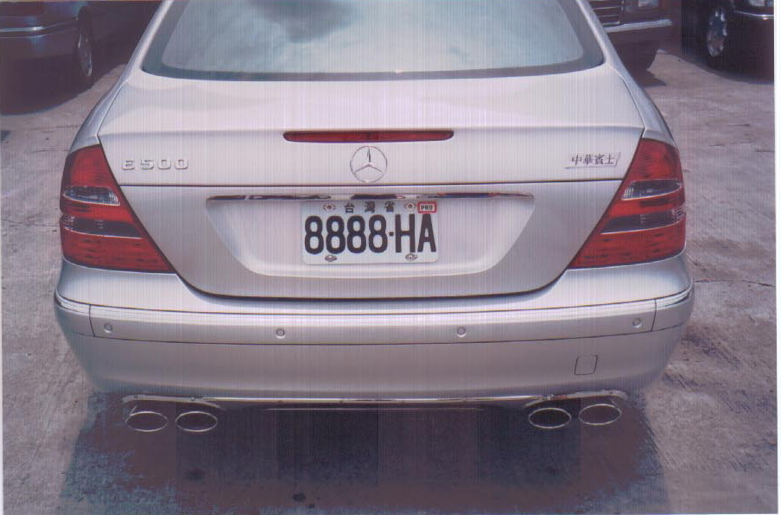  PICTURE 11 | 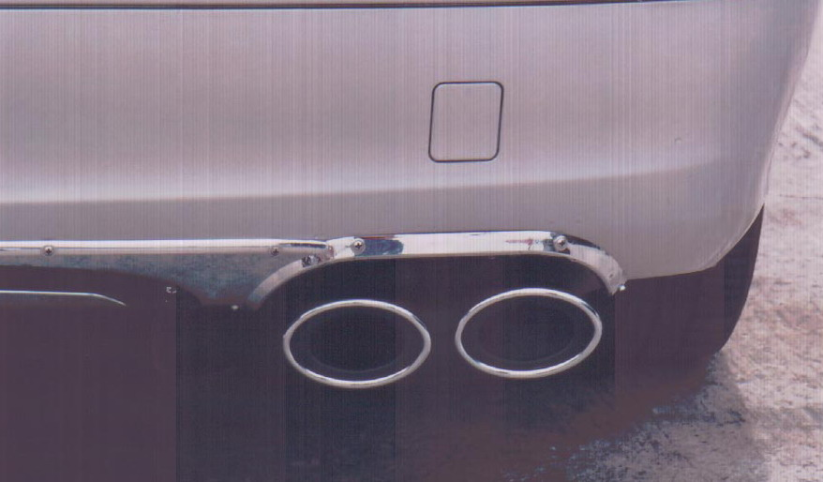  PICTURE 12

